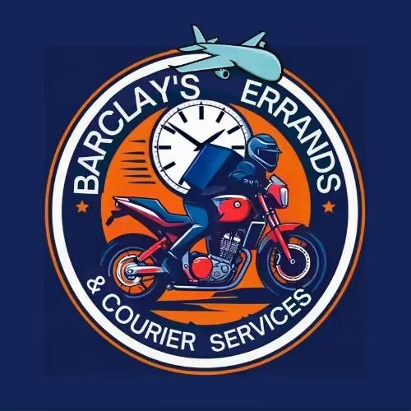

Terms and Conditions
Members of Barclayscourierja have agreed to use this service by accepting and abiding by the terms and conditions stated below.
You have agreed not to ship items that fall into any of the categories classified as hazardous by Barclayscourierja. Additionally, Barclayscourierja will refrain from shipping items that the customs office of Jamaica has prohibited. If you engage in such practices, you will be held liable, and any fees incurred will need to be paid, depending on the stage the product has reached in the shipping process.

You will be given a shipping and mailing address in the United States where your items should be sent.

You have granted Barclayscourierja permission to send you promotional information and other important messages via email or cell phone.

Signing up for the services of Barclay’s Errands & Courier Services does not attract a membership fee.

Products must be adequately packaged to withstand air transportation to ensure safe shipment with ordinary care in handling and to prevent injury or damage to any person or property.

Barclayscourierja will provide you with the option to insure items that are fragile and have a value greater than US$100.

Barclayscourierja will not be responsible for items damaged by external bodies, such as the companies from which you purchased online or Jamaican customs. We will only accept liability for products that are damaged or that went missing while in our possession.

You have granted permission to Barclayscourierja to clear your products on your behalf, and you agree to pay any fees charged by customs.

Customers will incur a service charge for goods that undergo customs inspection and charges.

Items that weigh over 75 lbs will incur an additional handling fee.

Starting 5 business days post-notification, uncollected packages will incur a JA$100 daily storage fee. After 1 week, the fee will double to JA$200 daily. Unclaimed items are auctioned after 44 business days or 2 months. No refund will be provided for deposits made on these shipments. Conditions Apply.

All package prices and contents must be inquired about at the office upon receiving. Barclayscourierja is not liable for any irregularities noticed after leaving the office.

If you have requested Barclayscourierja to conduct online purchases on your behalf using our credit card, you will be charged a small service fee for this service.

Our charges are subject to local sales tax or similar tax regimes.

Delivery will be provided to customers upon request, and a delivery fee will be charged.

The Company reserves the right to hold goods for an indefinite period where the customer has an outstanding balance. Barclayscourierja has the right to sell these goods in order to cover any outstanding costs on your account.

Full payments for shipments can be made before they are sent to our pick-up locations or delivered to customers. Otherwise, full payment is required unless prearranged with one of our representatives.

If Barclayscourierja requests additional documents and they are not provided, shipment may be delayed, and a storage fee will be charged after a certain period. Contact a representative for more information.

You accept liability for any sanctions experienced due to submission of fraudulent or invalid invoice

Packages may receive clearance fees depending on the nature of the item/s shipped

